Teaching of Handwriting at St. Mary’s

Statement of lntent
At St Mary’s Catholic Primary Academy we are committed to providing a safe and secure learning environment that is friendly, nurturing, inspiring and supportive for all learners.
Introduction
“Handwriting is a tool that has to work. It must be comfortable, fast and legible.” (Angela Webb, Chair, National Handwriting Association)
Children must be able to write with ease, speed and legibility. If they have difficulty, this will limit fluency and inhibit the quality and quantity of their work. It is important that the child’s handwriting becomes a skill that requires little effort and thought, so that creative and physical energy can be focused on the content of writing, rather than upon the act. We help children to achieve the steps towards independently using a continuous cursive style.

We aim for children to:
- Achieve a neat, legible style with correctly formed letters in a continuous cursive handwriting
- Develop flow and speed to aid expressing themselves creatively and imaginatively across the curriculum and for a range of purposes
- To automatically use clearly formed and joined handwriting in all of their writing
- Use their skills with confidence, in real life situations

Teaching and Learning
We use Read Write Inc in school, and we follow Read Write Inc’s principles in the teaching and modelling of handwriting.
Read Write Inc. teaches a casual cursive style with 7 lifts after lower case letters b g j p q y z.
Steps of teaching:
- Associate a sound with the shapes of the alphabet letters and, later, pairs of letters using the same picture mnemonics that have been used to teach them to read.
- Patterns relating to letter formations are first introduced using a variety of tools and multi-sensory methods. This develops free flowing hand movements and muscle strength.
- Letters are also introduced in varied, multi-sensory sessions: writing letters in the air, on backs or hands; orally describing letter shapes and joins with children using ‘letter speak’; using a variety of writing materials including whiteboards, chalk, paints, felt pens, crayons, plasticine, cornflour mix, shaving foam etc.
- Sit in a comfortable handwriting position and hold a pencil in a tripod grip.
- Form lower-case letters in the correct direction, starting and finishing in the right place. (Mnemonic phrases are used to mirror lower case printing.)
- Form lower-case letters of the correct size - relative to one another and to the size of the spaces between the words.
- Develop a style that adds an outgoing stroke to letters.
- Join letters using the two basic joins – diagonal and horizontal – as required by the National Curriculum programmes of study.
- As digraphs are introduced, their corresponding joins are taught.
- Correct pencil hold and letter formation are taught from the beginning and handwriting is frequently linked with spelling.

The cursive font, with lead-ins, is taught as a specific skill, at least twice a week for about 15 minutes, with additional, individual or group practice where necessary.
When marking or writing comments, members of staff use cursive handwriting as appropriate, using the school’s agreed letter formation.
Teachers model the relevant cursive script on IWB, whiteboards, flip charts etc.
Displays around the school and classroom should model clear joined handwriting as well as other fonts.
The cursive font should be displayed in classrooms to ensure familiarity with the style, alongside other printed and written formats.

Handwriting progression
EYFS | In the Foundation Stage, staff focus on getting children ready for handwriting by:  - Building the gross and fine motor skills needed for handwriting through structured games and activities  - The spatial awareness, visual and motor memory skills needed through non-pencil and pencil activities  - Supporting the children through the developmental pencil grip stages; including hand dominance identification  - Developing the children’s ability to correctly push and pull the pencil to be able to form letters correctly, firstly through pre-handwriting patterns and then single letter formation
Year 1 | Children should be taught to:  - begin to form lower case letters in the correct direction, starting and finishing in the right place  - form capital letters  - form digits 0-9  - understand which letters belong to which handwriting “families” (i.e. letters that are formed in similar ways, and to practise these  - The children are to begin to be taught and use exit lines when they are ready.
Year 2 | Children should be taught to:  - form lower case letters of the correct size relative to one another  - write capital letters and digits of the correct size, orientation and relationship to one another and to lower case letters.  - Use spacing between words that reflects the size of the letters  - Start using some of the diagonal and horizontal strokes needed to join letters, and understand which letters are best left unjoined.
Year 3 and Year 4 | Children should be taught to:  - increase the legibility, consistency and quality of their handwriting e.g. ensuring that the downstrokes of letters are parallel and equidistant and that lines of writing are spaced sufficiently so that the ascenders and descenders of letters do not touch  - When the children are producing consistently formed, sized and joined handwriting, they will be granted a ‘pen license’ and encouraged to write in pen where appropriate.
Year 5 and Year 6 | Children should be taught to write legibly, fluently and with increasing speed by:  - choosing which shape of a letter to use when given choices and deciding whether or not to join specific letters  - choosing the right implement that is best suited for a task

Techniques for teaching letter formation and joins
- Always model good handwriting
- Demonstrate formations
- Talk through the process
- Encourage children to verbalise the process
- Children form letters in the air and on parts of the body
- Finger trace over tactile letters
- Write in sand with finger or a stick

Basic structure of a handwriting session:
- Handwriting is taught and practised daily in all classes, and this can also be in the daily phonics and spelling sessions.
- Gross and fine movement warm up
- Posture check: feet flat on the floor, back straight and touching the chair
- Teacher modelling
- Children practising independently with a teacher model, then from memory

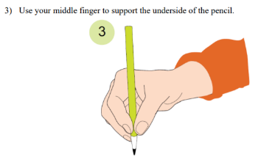
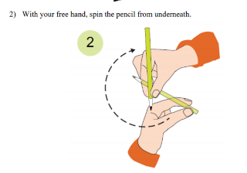
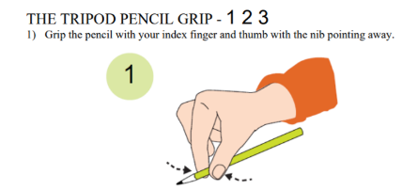
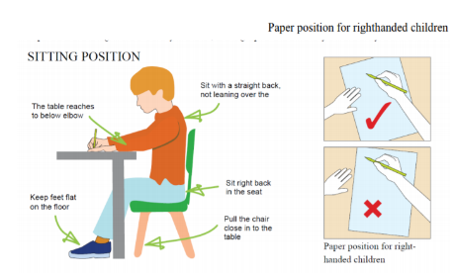

Provision for left handed children
Left handed children always sit on the left side of right handed children, so their elbows don’t bump and knock each other.
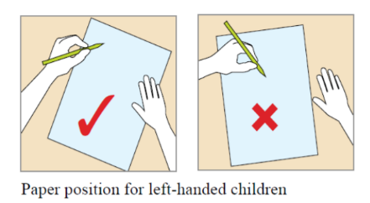
They are encouraged to find a comfortable orientation for their paper, usually slightly to the left centre of their body, and to have their fingers about 2-3 cm from the point of their pencil.
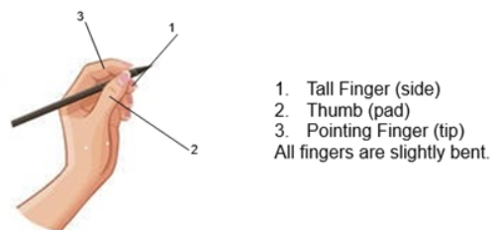
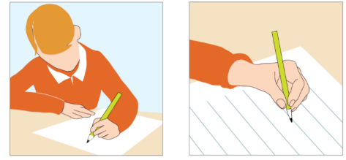

Resources and writing materials
Children are given experience of a variety of writing tools.
Pens should be used by those who have achieved a consistent, cursive style. They are to be used from the beginning of Year 5 even if the child has not yet received a pen license.
All children should write in blue ink, using the agreed Nexus pen.
The children are to practise their handwriting in the appropriate book chosen for this specific purpose.
Guidelines should be used when writing on plain paper.

Pupils with special educational needs or disabilities
The SENDCO will provide guidance and support for those who have difficulty with fine motor skills – pencil grips, fine motor control programmes and referrals where necessary.

Presentation
Pupils will learn that different levels of presentation are appropriate for different pieces of work and different circumstances. However, pupils are expected to:
- Look after exercise books and not draw or scribble in or on them
- Increasingly plan their work to make it look attractive and well presented
- Not use writing or drawing media that is not approved or not fit for purpose
- Use rulers to draw straight lines and underline all dates, titles and headings
- Set out, number and annotate work appropriately
- At appropriate times, pupils may be encouraged to experiment with alternative means of presenting their work for specific reasons.
- Cross through mistakes or editing alterations with a single line. Erasers should only be used very occasionally and with the express permission of an adult.

Teachers are expected to:
- Ensure that classrooms are well equipped with the essential tools that will assist pupils to create work with a high presentational standard
- Organise the classroom in such a way that materials and resources are easily accessible and systems for their return and maintenance are robust (self-service classroom)
- Ensure that children look after resources and materials so that they learn to respect equipment and good value for money is assured.

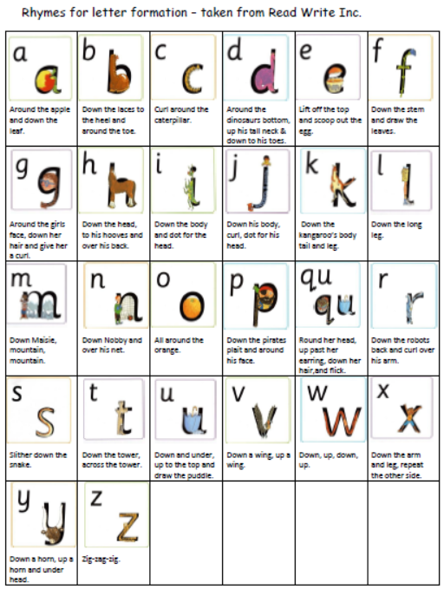
School’s agreed letter formation

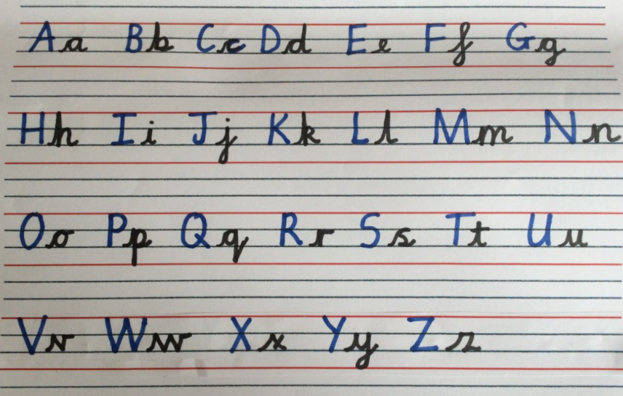

Policy Success Criteria
We know St Mary’s Catholic Primary Academy’s Handwriting and Presentation Policy is effective if:
- A scrutiny of work confirms the appropriate development in handwriting skills
- Specific difficulties are addressed in the marking of handwriting tasks
- A scrutiny of work confirms that the presentation protocol is adhered to

Equality Statement
St Mary’s Catholic Primary Academy provides a broad and balanced curriculum that meets the needs of all pupils, and promotes their spiritual, moral, social and cultural development. The school is committed to equality and reflects and values diversity.

Monitoring and Review
This policy is monitored by the English Lead and Head Teacher within the processes of school self-evaluation. The Governing Body will monitor the implementation of the policy. The policy will be reviewed every 3 years or sooner should National Policy change.

