Saint Mary’s Catholic Primary Academy
Nursery Medium Term Plan
Lent 1 – Dangerous Dinosaurs 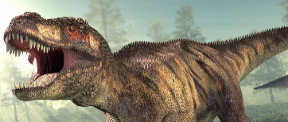
 | 2/1/23 | 9/1/23 | 16/1/23 | 23/1/23 | 30/1/23 | 6/2/23
Significant events | Back on 4th  Hook Days 4th, 5th 6th – create immersive classroom  Dinosaur and explorers dress up day | Dinosaur egg hatch | Martin Luther King Day 17th  Volcano Eruption | Chinese New Year | Edible Dinosaur Poo! | Parent celebration  -Dinosaur crafts  - Dinosaur games  - Dinosaur drawing  Valentine’s Day
Nature Focus | Lizards and Dragons | Eggs | Volcanos | Teeth | Poo | Footprints
Nursery Rhymes | Wind The Bobbin Up | It’s raining it’s pouring | Pat a cake | Teddy bear Teddy bear | If You're Happy and You Know It
Book Focus | 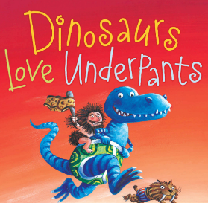 | 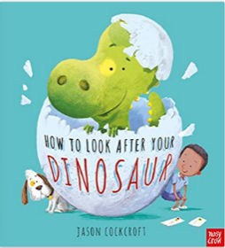 | 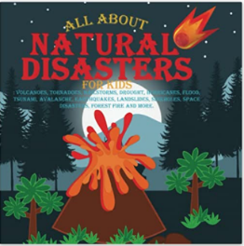 | 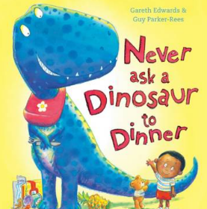 | 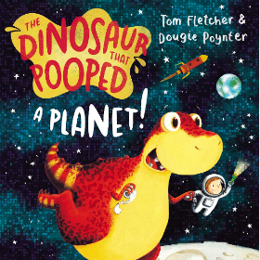 | 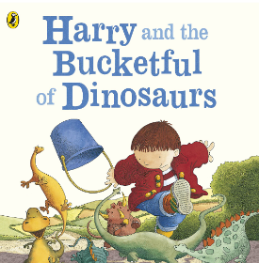
Vocabulary | Dinosaur names,  Fossils, scales, teeth, bones, sharp, rough, biggest, smallest, claws, meat, plants, explode, poo
Knowledge
RE | Celebrating  Learning Intention  To know what a celebration is and how people celebrate. | Celebrating  Learning Intention  To know the term ‘Parish Family’  To know God knows and loves me. | Celebrating  Learning Intention  To know how parish family celebrates. | Celebrating  Learning Intention  To know the connection between celebration and the parish family. | Gathering  Learning Intention  To know some similarities and differences between different religious and cultural communities in this country, drawing on their experiences and what has been read in class. | Gathering  Learning Intention  To know some similarities and differences between different religious and cultural communities in this country, drawing on their experiences and what has been read in class.
Literacy | Dinosaurs Love Underpants  Learning Intention  To know what rhyming words sound like. | How to look after a dinosaur  Learning Intention  To know what instructions are.  To know chronological language (first, second etc.) | Natural Disasters  Learning Intention  To know the vocabulary of describing sounds in natural disasters (onomatopoeia) | Never ask a dinosaur to dinner  Learning Intention  To know what rules are and how they are written.  (write their own set of rules) | The dinosaur who pooped a planet  Learning Intention  To know the meaning of new vocabulary and how to use it in conversation. | Harry and his bucketful of Dinosaurs  Learning Intention  To know the sequence of the story to write their own version.
Maths | Exploring 1  Learning Intention  To know how number 1 is represented with objects. | Exploring 1  Learning Intention  To know what the numeral 1 looks like and where is goes when counting. | Exploring 2  Learning Intention  To know how number 2 is represented with objects. | Exploring 2  Learning Intention  To know what the numeral 2 looks like and where it goes when counting. | Exploring 3  Learning Intention  To know how number 3 is represented with objects. | Exploring 3  Learning Intention  To know what the numeral 3 looks like and where is goes when counting.
RSE |  | Religious Understanding  Learning Intention  To know why the Bible is so special to Christians | Who’s who  Learning Intention  To know and apply names to different family relationships, as well as discussing ‘special people’ who they can trust. | You’ve got a friend in me  Learning Intention  To know about friendships with peers and the different qualities of a positive/negative relationships | Forever Friends  Learning Intention  To know that when we hurt others, we also hurt Jesus – but that Jesus teaches us how to forgive ourselves and others.
Topic | Lizards and Dragons  Learning Intention  To know the characteristics of reptiles. (Science) | Eggs  Learning Intention  To know some animals come from eggs. | Volcanos  Learning Intention  To know what volcanos are and that they erupt. | Teeth  Learning Intention  To know what teeth are used for.  To know who has teeth. | Poo  Learning Intention  To know Living things like dinosaurs, plesiosaurs and pterosaurs lived millions of years ago. | Footprints  Learning Intention  To know the differences in footprints and the animals they belong to.
Skills

Personal Social and Emotional | Children will be able to show more confidence in new social situations.  They will be able to talk about their feeling using words like happy, sad, angry or worried  They will be increasingly independent in meeting their own care needs.
Physical Development | Children will continue to develop their movement, balancing, riding and ball skills.  They will use large muscle movements to wave flags and streamers paint and make marks.  They will continue to match their developing physicals to task and activities in the setting  Children will be able to use one handed tools and equipment  They will continue to become increasing independent as they get dressed and undressed
Communication and Language | Children will be able to sing a large repertoire of songs.  Children will begin to talk about familiar books and be able to tell a long story.  Children will begin to start conversations with adults or other children and continue for many turns.
Literacy | Children will know that we read English text from left to right and from top to bottom.  They will continue to develop phonological awareness to spot and suggest rhymes.
Maths | Children will know how to recognise the numbers 1, 2 and 3.  Children will begin to write the numerals 1, 2 and 3.  Children will be able to represent the numbers 1, 2 and 3.  Children will be able to compare the numbers 1, 2 and 3  Children will be able to order the numerals 1 2 and 3.
Understanding the World | Children will be able to talk about what they see using a wide vocabulary  They will begin to understand the need to respect and care for the natural environment and all living things  They will be able to talk about what they see using a wide vocabulary.  They will understand the key features of a life cycle of an animal.  .
Expressive Art and Design | Children will be able to use drawings to represent ideas like movement and loud noises.  They will make imaginative and complex ‘small words’ with blocks and construction kits.  They will be able to explore different materials freely, to develop ideas about how to use them and what to make.  To join different materials and explore different textures.

