*St. Mary’s Catholic Primary School*

RE Newsletter Spring 1

*Be the light to those around you!*

Dear Parents/Carers, 9th Jan – 10th Feb 2023

We begin this term full of the joy of the Christmas season which ends for us at the celebration of the Baptism of Jesus on 9th January. On the 2nd February we celebrate the feast of the Presentation of the Lord (Candlemas) when Jesus is recognised as ‘The Light of the World’. We must also remember that each one of us is called to be a ‘light’, an inspiration to those around us.

In this issue of the newsletter you will find what your child is learning about in each year group. We hope you find this newsletter of interest and as always, please keep us in your prayers as we continue to support your children in their religious education.

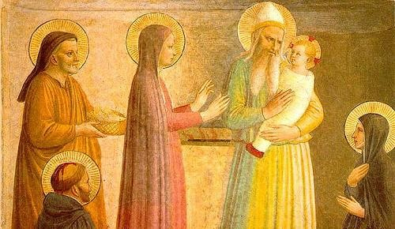

Dates from the Church’s calendar:

During the winter of Ordinary Time, i.e. up to Lent, we are asked to pray for these intentions: **Peace on Earth**; **Christian Unity**; **The Sick and Those Who Care for Them**; **Victims of Trafficking and Those who Work to Combat it**; **The Unemployed**.

6th January 9th January 12th January 17th January 24th January 25th January 26th January

**The Epiphany of the Lord** 28th January

**The Baptism of the Lord** 31st January

St. Aelred of Rievaulx

2nd February

St. Anthony (desert Father) 3rd February

St Francis de Sales

**Conversion of St. Paul**

Ss Timothy and Titus

8th February

St. Thomas Aquinas

St. John Bosco **Presentation of the Lord** St. Blaise

St Josephine Bakhita

11th February Our Lady of Lourdes

# Reception - Getting to know Jesus

This half term, children in Reception will be getting to know Jesus. Throughout the unit, the children will be given opportunities to become aware that Jesus has a great love for each one of us and will think of ways in which we can show our love for Jesus. They will hear that Jesus cured people who were sick and think of ways we can show our love for sick people.

At home

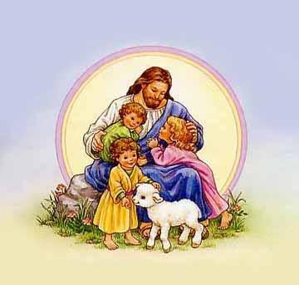

You could help your children by:

* saying or sharing prayers together
* talk about people who help us e.g. nurses, doctors
* talk about how we can help others
* giving them jobs which help at home

# Year 1 – Families and Celebrations

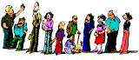

## “The Christian family … can and should be called a domestic church. It is a community of faith, hope and charity”

*Catechism of the Catholic Church*

The children will learn about what it means to be a member of a family and to be a member of the school community. They will learn what it means to belong to the Church family.

They will hear how Jesus’ family took him to the Temple and think about why this was a special occasion. They will learn about some of the celebrations in the Church and why we celebrate these occasions.

At home

You could help your children by:

* discussing the importance of celebrations in our lives
* talking to your child about their baptism

# Year 2 – The Good News

## “Jesus is sent to preach good news to the poor. Jesus identifies himself with the poor of every kind and makes active love toward them the condition for entering his kingdom.”

*Catechism of the Catholic Church*

The children will learn that Jesus brought the good news of God’s love and that this changed people’s lives. They will learn that Jesus used his power to help others and reflect on the importance of these events.

They will reflect on how they can bring good news to their family and friends. At home

You could help your children by:

* highlighting opportunities when they can give thanks to God
* read stories about Jesus helping people, e.g. The feeding of the 5000

# Year 3 – Jesus the Teacher

The children will learn that Jesus was born into a Jewish family. They will learn that Jesus attended synagogue as a child and as an adult read the Torah. They will learn that Jesus travelled about teaching people.

The children will learn that Jesus came to show us the way to live, understand why Jesus used parables to teach people and know and understand some of the parables Jesus told. The children will have a chance to appreciate the relevance of the parables for us today.

At home:

You could help your children by:

* read some well known parables, e.g. ‘The Sower’ and talk about what they mean for us

# Year 4 – Celebrating the Mass

**“In the Eucharist we receive Christ as our life and food, a promise of the eternal banquet of heaven. At the heart of the Eucharistic celebration are the bread and wine that become in reality Christ’s Body and Blood. Catholic faith adores this enduring presence of Christ not only within the celebration of the Mass but also outside it.”** *Religious Education Curriculum Directory*

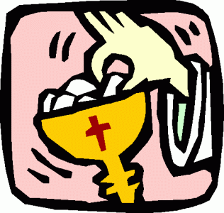

Year 4 will know why Sunday is special for Christians and will know that we

come to Mass to hear the teaching of Jesus and pray to him. They will learn that in the Mass we offer thanks to God the Father for the gift of his Son and learn that during Mass the bread and wine become the body and blood of Jesus. They will learn that when we receive Holy Communion we receive Jesus and learn that Jesus is present in the Blessed Sacrament in the tabernacle. They will also learn some of the responses in the Mass and understand that Jesus died on the cross, and rose from the dead.

At Home

You could help your children by:

* talking to them about all the things we have to be thankful for
* talking to them about how Sunday is a special day for Christians

# Year 5 – Inspirational People

***“Love of neighbour … involves working for a just society… It includes love for the poor. Love of neighbour is also an expression of our search for God.”*** *Religious Education Curriculum Directory*

The children will learn about the conditions for following Jesus and learn how Jesus described a true disciple. They will have a chance to reflect on their commitment to following Jesus or their own faith. They will learn the story of a person who had a special love for those rejected by society and about someone who was an inspiration for young people. They will identify people today who are an inspiration in their service of others.

At home:

You could help your children by

* encouraging them to research some information about inspirational people and saints

# Year 6 – Jesus, the bread of life

## “At the heart of the Eucharistic celebration are the bread and wine that become in reality

***Christ’s Body and Blood. Catholic faith adores this enduring presence of Christ not only within the celebration of the Mass but also outside it.***”

*Religious Education Curriculum Directory*

The children will learn that the Sacrament of the Eucharist is a thanksgiving for the life, death and resurrection of Jesus.

They will learn the different parts of the Mass and become familiar with most of the responses. The children will learn that the bread and wine are consecrated during Mass and become the body and blood of Jesus. The children will have a chance to reflect on the sacrifice of Jesus and reflect on the sacrifices they can make during Lent.

At home:

You could help your children by:

* Challenging them during the week to describe what they have been learning during their RE lessons asking them to explain it to you.