Dear Parents/Carers

It is lovely to see all the children and yourselves back after the summer holidays. I would ask that you read carefully the notices in this month’s newsletter, especially in relation to the dates throughout the term and the arrangements for collecting the children at the end of the day.

It is our intention to invite parents to our end of week assembly, commencing this Friday. We hope to establish a parent reading club after mid-term. Further details will follow.

The Early Years Unit is near approaching completion following an extensive refurbishment. We will be inviting all parents from EYFS to visit the unit after mid-term. This will be communicated via Dojo.

October is the month of the Holy Rosary and children will have the opportunity to join the Rosary Club managed by the Chaplain each Thursday afternoon.

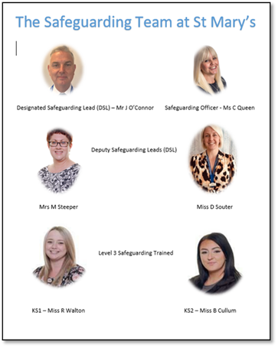

Dates for the Diary

Friday 6th October
Celebration Assembly

Monday 16th October
Flu Vaccinations

Friday 20th October
Break Up for Half Term

Tuesday 31st October
Back to School

November
School Photographer (Date to follow)

Wednesday 20th December
Close for Christmas

Wednesday 3rd January
Back to School

Catholic Life at St Mary’s
Celebration Assembly - We would love parents and carers to join us on a Friday afternoon, every two weeks, in our whole school Celebration assembly. This will start on Friday 6th October at 2.50pm. Please come to the hall door to sign in. Children will still be leaving at normal home time of 3.20pm from the playground.

The month of October is dedicated to the Holy Rosary.

"Since the prayers of the Rosary come from such excellent sources — from Our Lord Himself, from inspired Scripture, and from the Church — it is not surprising that the Rosary is so dear to our Blessed Mother and so powerful with heaven.

What is the purpose of Rosary?
The purpose of the Rosary is to help people remember
the events in the lives of Jesus and Mary and to thank
and praise God for them. The Rosary Prayer is a little
bit like a history lesson!
The main focus is on Jesus - his birth, life, death
and resurrection.

What is the holy Rosary?
The Rosary is a form of prayer used especially in the Catholic Church.
It is a long prayer, based on repetition, with many parts to be remembered
and said. It is named after the string of prayer beads which some people use to count
the parts of the prayer. The Rosary Prayer is very important to Catholics for many reasons, including
their devotion to Mary. The Rosary Prayer can be said alone or in groups.

Fear not, Mary, thou hast found grace with the Lord; behold, thou shalt conceive and bring forth a son, alleluia.

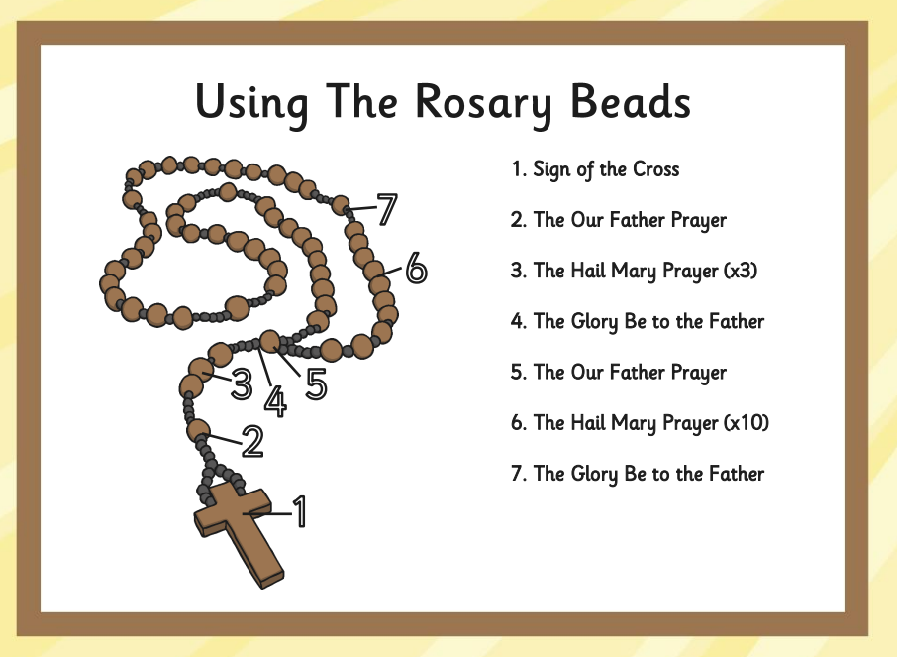

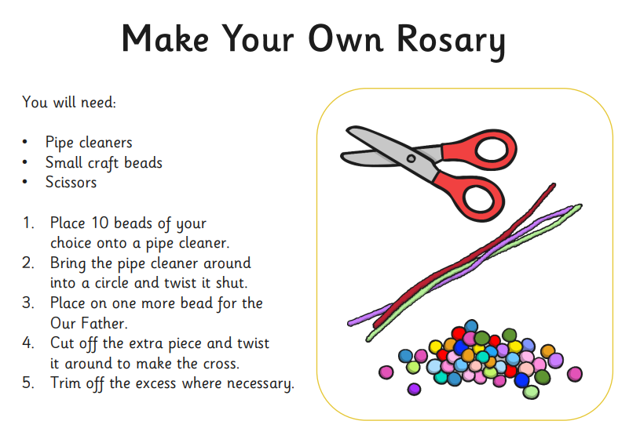

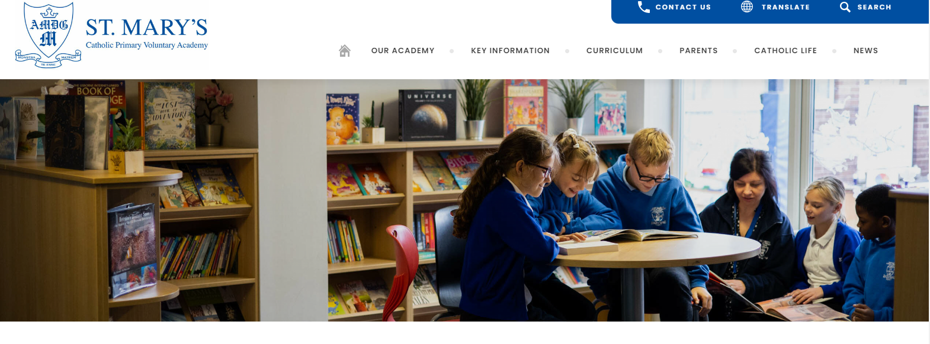
School Website and Class Dojo

Please visit the school website for updates on your children’s work, polices and up to date guidelines and information.

We are in the process of updating all the class pages.

https://www.saintmarysprimarygrimsby.co.uk/

Please use class Dojo for daily updates. If you would like access, please ask the class teacher for access to this. Thank you

Reminder to keeps forms updated.

We have a medical, photography and a permission form to take home that need to be kept updated. If you haven’t received one of these, or if any need updating, please pop to the office. Thank you.



Attendance - Absences

If you are planning to take your child out of school for any reason other than a medical appointment that cannot be arranged out of school time, please contact the school office to fill in a request for leave form.
If you fill one of these forms in, then the decision can be made whether the absence is authorised or unauthorised.
If you fail to fill a form in with enough notice, then the absence will be unauthorised. Unauthorised absences are reported to the Education Welfare Officer and a fine could be issued.

It is your responsibility to inform school on each day of absence. Please do this by calling the school office on 01472 357982 before 9am. You can also email the school office at office@smp.nelcmail.co.uk or send a message on the Scholarpack app.



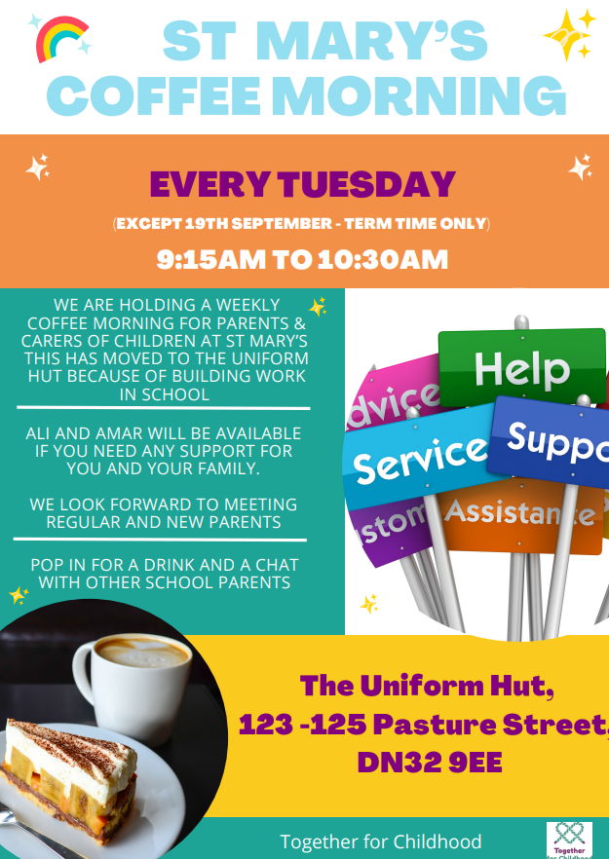



End of day routine

Gates will open at 3.15 p.m. for the end of the school learning day at 3.20 p.m. Parents must line up behind the cones on the playground. Staff will lead out classes and line up on the playground to dismiss children individually. No child will be dismissed to anybody who is not on the nominated list. They will not be dismissed to a minor (if a sibling is collecting them, then they must be at secondary school and be on the nominated list).

If there is a last minute arrangement for collection, then the office can be contacted and the password for collection provided by that person.

No adult will be allowed to call a child to come to them or take a child from the line. The teacher must dismiss.

This is for the safeguarding of all children.

Members of the Senior Leadership team will be available at the end of the day as well.
