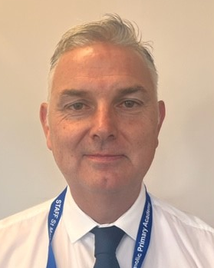

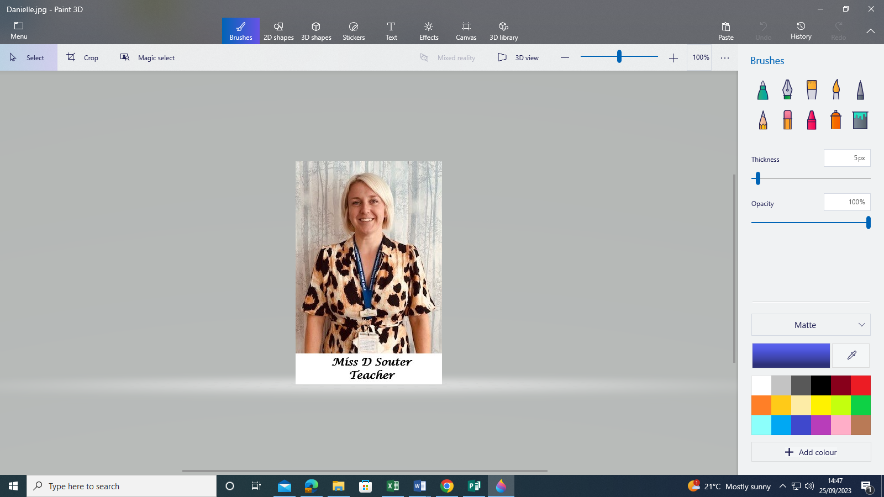

Mrs K Tuff, Well-being, Personal Development and RE Lead

Mrs K Tuff

Miss R Cullum, Level 3 Safeguarding Trained

Mrs L Ballard, Deputy Safeguarding Lead (DDSL)

Mrs D Williamson, Deputy Safeguarding Lead (DDSL)

Mrs M Steeper, Deputy Safeguarding Lead (DDSL)

Safeguarding Officer/DDSL Ms C Queen

Mrs R Walton, Level 3 Safeguarding Trained

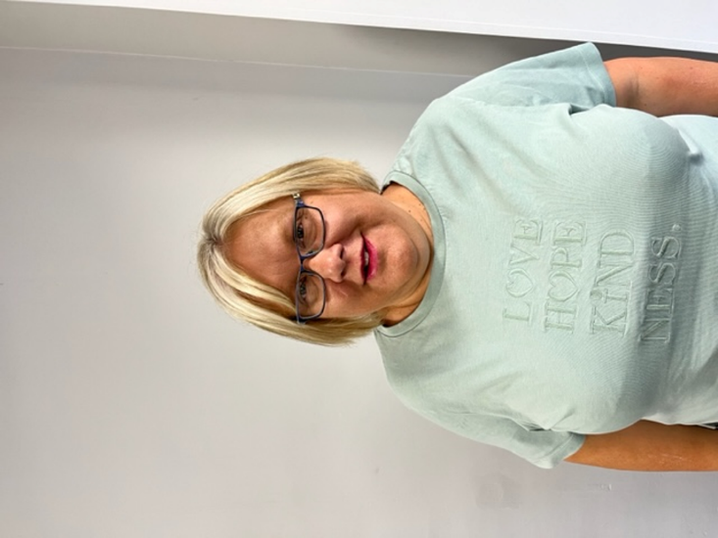









Miss J Briscoe, Level 3 Safeguarding Trained

Safeguarding Lead (DSL) – Mr J O’Connor

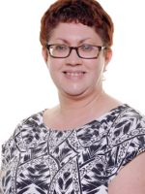

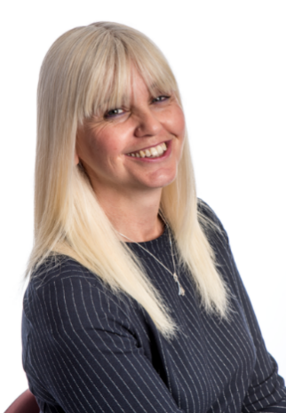

**St Mary’s Primary Academy - Safeguarding Team**

