
Mr J O’Connor, Safeguarding Lead (DSL)
Ms C Queen, Safeguarding Officer/(DDSL )
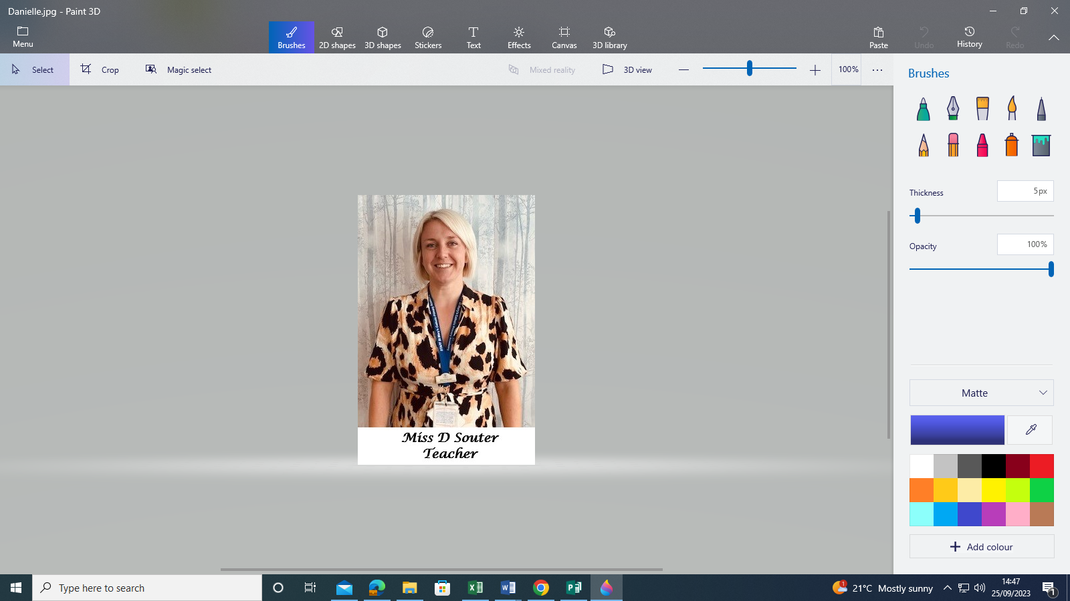
Mrs K Tuff, Well-being, Personal Development and RE Lead
Mrs K Tuff

Miss R Cullum, Level 3 Safeguarding Trained
Mrs L Ballard, Deputy Safeguarding Lead (DDSL)
Mrs D Williamson, Deputy Safeguarding Lead (DDSL)
Mrs S Barnsley, Deputy Safeguarding Lead (DDSL)
Mrs R Walton, Level 3 Safeguarding Trained
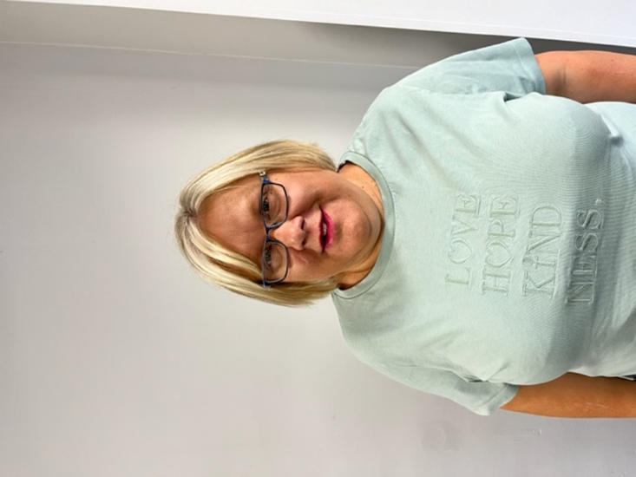




Miss J Briscoe, Level 3 Safeguarding Trained
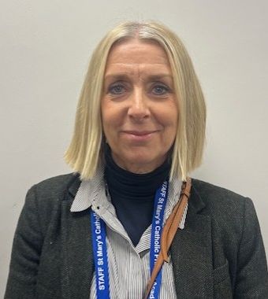

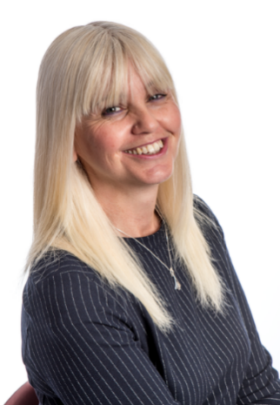
St Mary’s Primary Academy - Safeguarding Team

