Dear Parents, Carers, and School Community,
The month of March is dedicated to St Joseph. The entire month falls during the liturgical season of Lent which is represented by the liturgical colour purple — a symbol of penance, mortification and the sorrow of a contrite heart.
As we continue our journey "up to Jerusalem" during the month of March, three prominent ideas are proposed for our contemplation by the liturgy of Lent: the Passion and Resurrection of Christ, baptism, and penance.
The Solemnity of St. Joseph is a special landmark this month in which we will celebrate the great honour bestowed upon the foster father of Jesus. And if you are Irish, St. Patrick's feast is another cause for a joyful celebration (March 17). The feast of the Annunciation is celebrated on March 25.
May I take this opportunity to thank you all for your kind words of encouragement and support during my return to St Mary’s following ill health. I currently remain on a phased return and will resume full duties the final week before Easter. I should like to pay tribute and extend again, my warmest thanks to Mrs Barnsley for everything she has done and continues to do.
Every good wish

Mr Joseph O’Connor

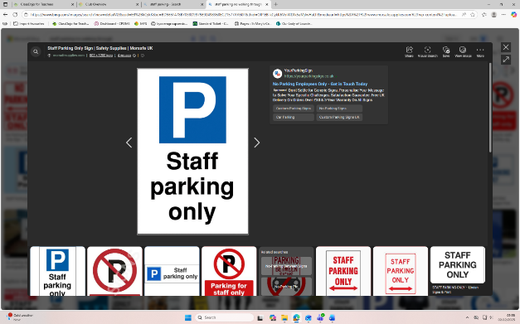
STAFF CAR PARK
It has been noticed that some parents are using the staff car park when picking up and collecting. This is a reminder that the staff car park is for staff and deliveries only. Please do not park or walk through the car park at any time. We request this to make sure you and your children remain safe at the start and end of the day.




Dates for the diary
(More important dates/times to be added please keep checking Class Dojo)
*Some sport competitions are for selected children only and you will be notified on dojo via Mrs Solomou if your child is selected.

Monday 9th March / Year 5 and Year 6 Self Esteem Workshop @ School
Thursday 12th March / Year 5 and Year 6 Tag Rugby Competition
Tuesday 17th March / Year 5 Art Workshop at Clee Academy
- Parent and Carer Well-Being Workshop with PINS Training in school at 1.30pm-3pm
Friday 20th March / Red Nose Day (Details to follow)
Wednesday 25th March / Theme Day – Easter Celebration for Lunch
Thursday 26th March / Resurrection Rocks for Year 4,5 and 6
(9.45am Performance to the school and 2.30pm Performance to Parents and Carers in the Hall)
NO AFTERSCHOOL CLUBS LAST WEEK OF TERM W/C 30th MARCH
Tuesday 31st March / Good Friday Mass at 9.30am in Church
(Parents and Carers welcome to join)
Thursday 2nd April / Awards Assembly
(9.30am in the Hall-Parents and Carers welcome to join)
Friday 3rd April / School Closed as Bank Holiday
Monday 6th April – Friday 17th April / School Closed – Easter Holiday
Monday 20th April / Teachers Training
Tuesday 21st April / Children back to school
Wednesday 22nd April / Matilda drama workshop Year 5 and 6 at Clee Academy

Please order lunches by Sunday 5th April for Meals commencing Monday 20th April via Arbor
(New menu will be uploaded in the next 2 weeks)





INFORMATION YOU NEED TO KNOW
Breakfast Club and school lunches
Please book breakfast club via Arbor App. This runs from 7.45am and children have breakfast and join in on some fun activities with their friends. Lunches must also be booked on Arbor 2 weeks in advance. Please make sure your account is topped up every month.
AFTERSCHOOL CLUB
Please book afterschool clubs via Arbor App. These run from 3.30pm-4.30pm and collection from hall door. Parents must advise the office staff if any of their children in Year 5 or Year 6 are walking home. Reminder Dance is now on a Thursday.
Permissions to take home and medical forms
Please can all information be kept updated. It is parents/carer responsibility to keep all information updated for your child/children, especially any new medical information. This can be seen on the Arbor App and you can request changes and updates on there.
FORMS
Please can parents/carers fill and update the Pupil Consent Form. If you haven’t received a copy, please ask the office.
School Website
https://www.saintmarysprimarygrimsby.co.uk/ please visit the school website for all updated information on the school.
Safeguarding Team at St Marys
Mr J O’Connor - Safeguarding Lead
Ms C Queen - Safeguarding Officer
Mrs S Barnsley - Safeguarding Lead
Mrs L Ballard - Deputy Safeguarding Lead
Mrs D Williamson - Deputy Safeguarding Lead
Mrs R Walton - Level 3
Miss J Briscoe - Level 3
Miss B Cullum - Level 3
Mrs K Tuff - Well-being, personal development and RE Lead


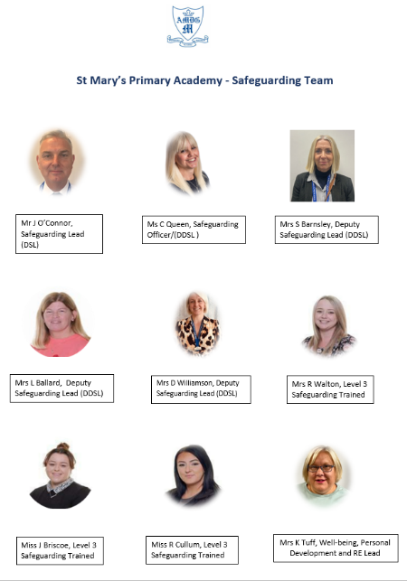

EASTER CELEBRATION THEME DAY
If you have ordered below main or vegetarian on Wednesday 25th March

-Roast Chicken (Main)
-Cheese and Onion Pasty (Vegetarian)
It will be below
-Roast Turkey & Yorkshire Pudding with Roast Potatoes & Gravy

-Roast Quorn & Yorkshire Pudding with Roast Potatoes & Gravy

-Jacket Potato with Cheese & Beans

-Ham Sandwich

-Cheese Sandwich

Dessert (Choose on the Day)

-Easter Lemon Drizzle Cake



WEAR RED DAY – CAKE SALE
Thank you to our parents and carers for either donating, bringing in sweet treats or buying our cakes and biscuits at our cake sale. This charity means a lot to us at St Mary’s, and we are thankful for all your continued support. Overall, a fantastic amount of £234.45 was raised.
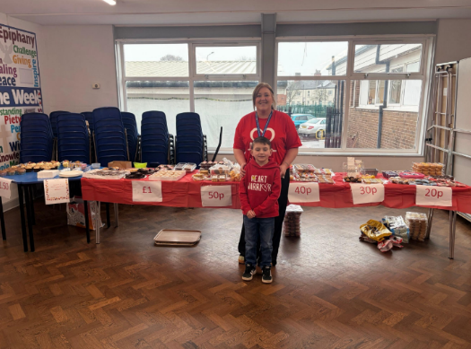


CHILDRENS MENTAL HEALTH WEEK – NSPCC NUMBER DAY
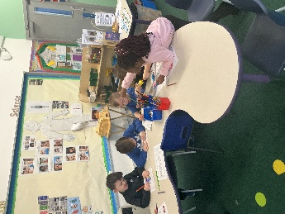
This year, our school proudly celebrated Children’s Mental Health Week, taking time to focus on wellbeing, self-expression, and the importance of looking after our mental health. We also took part in NSPCC number day, a special event dedicated to celebrating mathematics in fun, engaging, and meaningful ways across the whole school community. Thank you to all the parents and carers of St Mary’s for donating. We raised £72 for Children Mental Health Week and £82.70 for NSPCC - Well done!!
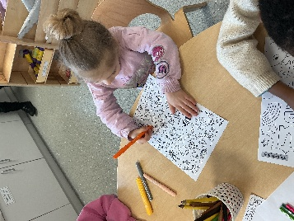
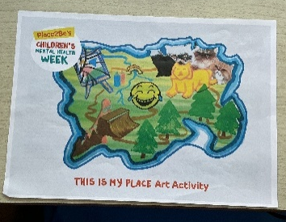
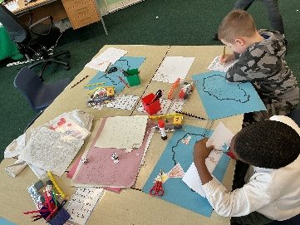
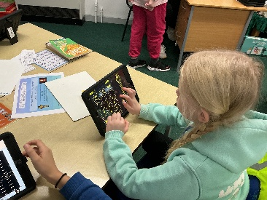

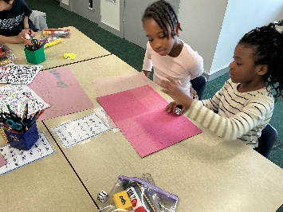
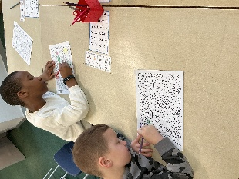
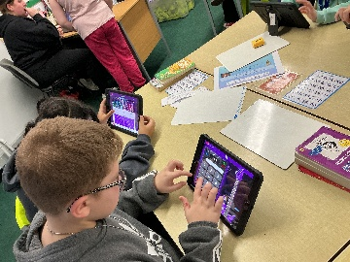

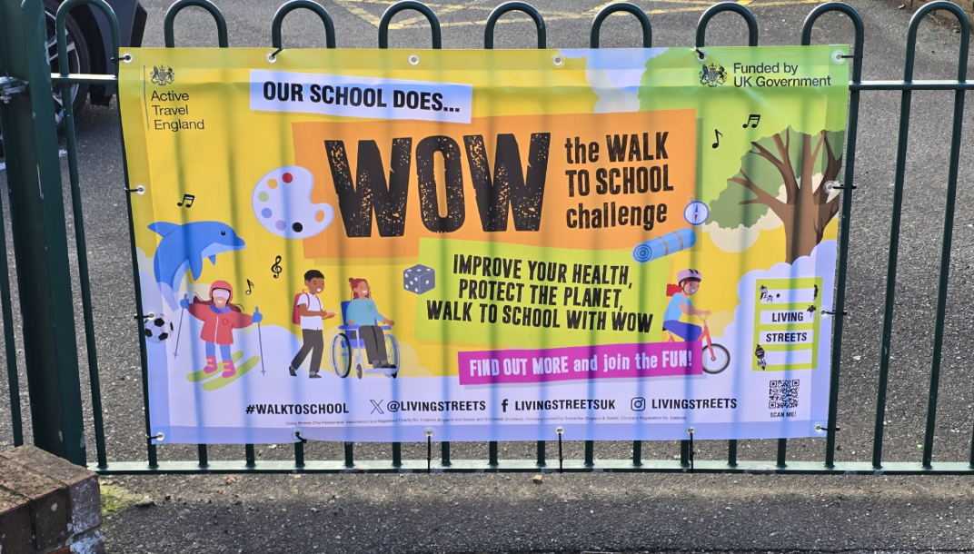
THE WALK TO SCHOOL CHALLENGE

As a school we are proud to be supporting WOW - The Walk To School Challenge.
WOW Travel tracker
The WOW Travel Tracker is a digital system that allows pupils to log their daily journeys to school and earn badges for walking, cycling, scooting or wheeling at least once per week.
Overview
The WOW Travel Tracker is part of the Living Streets Walk to School initiative, designed to encourage children and families to travel actively to school. Pupils can record their journeys on classroom interactive whiteboards, PCs or iPads, and the system tracks all modes of travel, including walking, cycling and scooting. The tracker uses icons to represent pupils, with optional name tags for classrooms that prefer them.
Rewards and Motivation
Pupils who travel actively at least once per week for a month earn a WOW badge with 11 badges available each school year. These badges are designed by pupils and serve as a motivational tool to encourage consistent participation.

CATHOLIC LIFE AT ST MARYS
Towards the end of last term, the student council decided on creating activities for the prayer tables around the school corridors and the quiet prayer area. They thought about what Lent actually means (the forty days that Jesus was in the desert and was tempted by the devil.)
As a Catholic diocese, we are given the Word of the Week resources and these words for Lent are prayer, fasting and almsgiving. With these in mind, the student council decided to focus our prayer tables on these.
This is what they decided:
- - Our prayer themed focus table is about asking for forgiveness and writing our own sorry prayers or drawing a picture about God always loving us.
- Our fasting prayer station asks us to write or draw something that we are trying to give up for Lent.
- Our almsgiving prayer station asks us to think about a kind action we could do for others. We could write this down or draw a picture to show how we can do this.
- Finally, for our quiet prayer area, Lent is a time to draw closer to God: We put out this poster to help us think about how we can build a personal prayer life with God and take a few minutes out of our day to spent time with God:

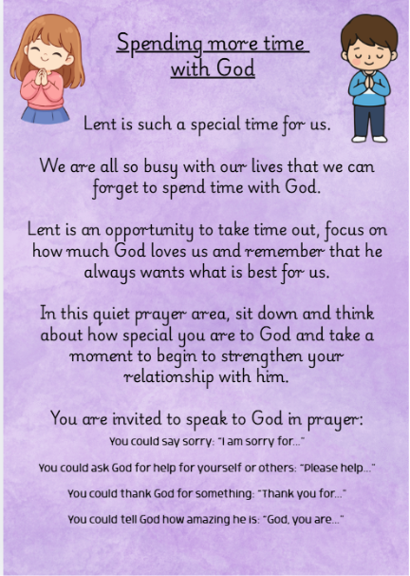

WHAT WE HAVE BEEN UP TO IN CLASS

In RECEPTION CLASS we have moved onto our length, height and time topic in maths. Children have enjoyed measuring different items around the classroom and are using words like longer and shorter to describe different items. It was great to see the children measuring each other and then explaining who was the tallest and shortest.
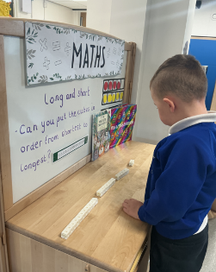
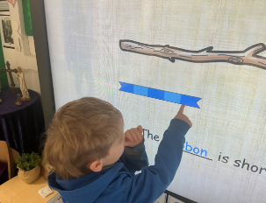
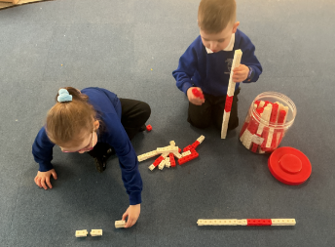
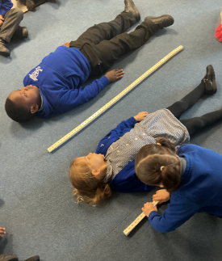
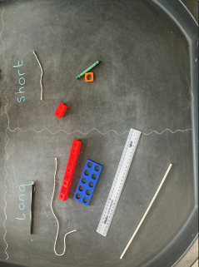

YEAR 1 children have been learning about movement of vehicles in their DT lessons. They have been learning about the use of wheels, axles and chassis. They experimented moving objects with wheels to see how it makes a task easier. Then they made their own vehicles using 4 wheels, 2 axles and a chassis. For children’s mental health day children relaxed in class with mindfulness colouring and relaxing music.

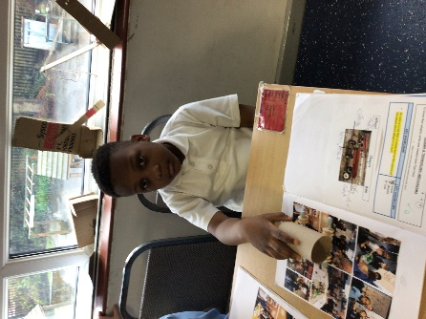
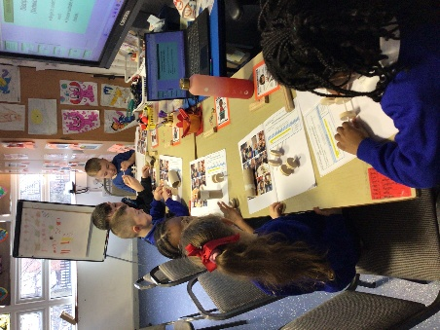
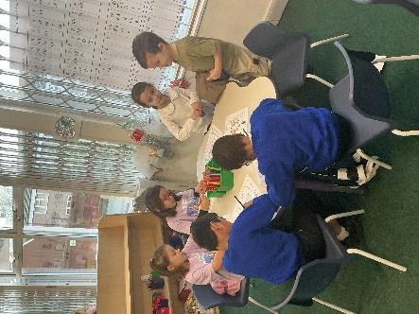
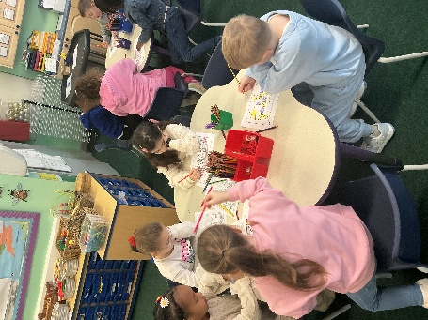

In YEAR 2 English we are preparing to write a non-chronological information text about our school. Children have been learning to use commas when writing a list. In Reading skills, children have been exploring new vocabulary to help understand the text. Children were tasked to match the definitions with the correct words. In RE we have been learning about Jesus’ journey from Galilee to Jerusalem. We recapped his Baptism recreating our own artwork inspired by the many famous paintings of this story. We also listened to many of the miracle stories and parables from the Bible, and how important these are for our understanding of who Jesus was and his teachings.
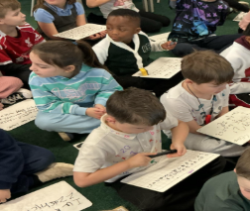
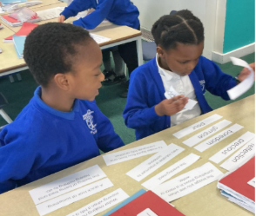
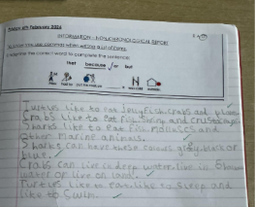

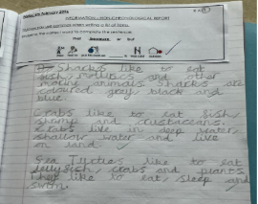
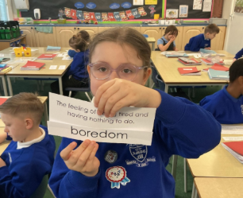
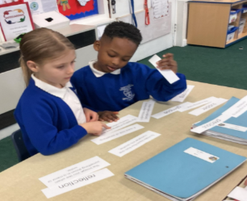

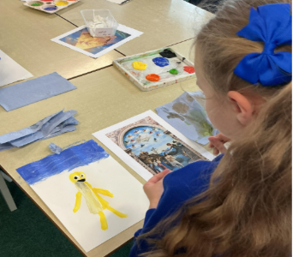
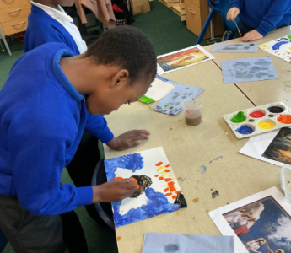
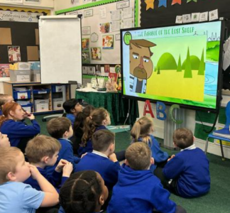

YEAR 3 have started our new PE orienteering topic. We had a challenge of rearranging yourself on the bench without talking. We discussed how we had to work as a team and use gestures. We got in numerical order, height order and alphabetical order. It was super tricky not being able to talk and stay on the bench while moving past each other, but the children got quicker and started thinking of how to make it even harder! In English, the children have been learning how to write clear instructions. They have been exploring the key features of instructional writing such as using imperative verbs, organizing steps clearly, and writing in the correct order. Over the coming weeks, the children will also begin planning and writing their own myth, using their imagination to create exciting characters and settings.
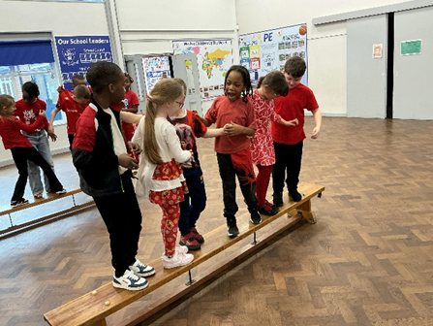
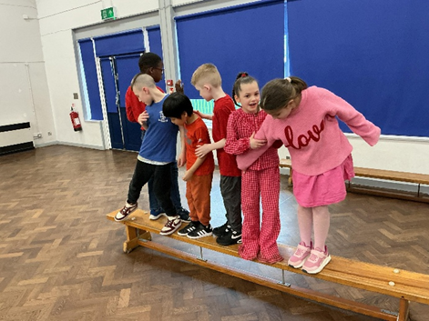
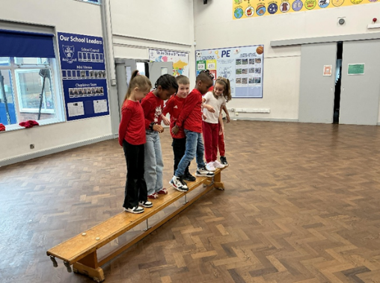

In YEAR 4 swimming lessons will conclude this term, so the children are currently completing their assessments to see which badges and certificates they are able to achieve. The children have been one of the first classes to make use of the refurbished pool and have made amazing progress and shown great resilience. This half term in Science, Year 4 will be learning about grouping and classifying living things. We will explore how scientists use classification keys to identify and sort organisms based on shared characteristics. We will learn the difference between vertebrates and invertebrates, identifying features such as backbones, exoskeletons, feathers, fur and scales. We will study plant classification, distinguishing between vascular and non-vascular plants, and understanding how plants transport water and nutrients. Finally, we will examine how humans can positively and negatively impact habitats and ecosystems. Throughout the unit, children will develop their enquiry skills by asking questions, making observations and communicating their findings clearly. Here are some photos from our French lesson learning different words for the weather and practicing our pronunciation.
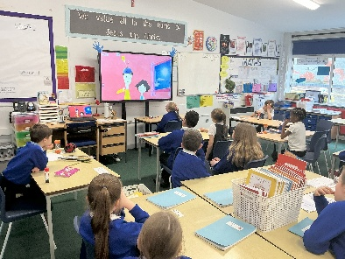
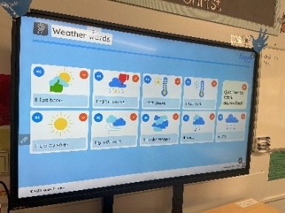
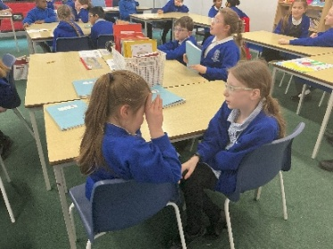

Our focus for Lent term 2 in YEAR 5 for Writing is a historical narrative. We are writing about the iconic Great Fire of London and considering how we can uplevel our writing by carefully crafting our sentences in our edit and improve stage once our initial ideas are on the page with the goal of building suspense. Our motto has become "SHOW not TELL!" We kicked off the unit with a sensory experience - the smell of smoke, a distant crackling sound, dim lighting... We even had members of staff thinking something was on fire! The children were so inspired, and we can't wait to start drafting our ideas. Keep an eye on Year 5's ClassDojo for children reading extracts of their work.
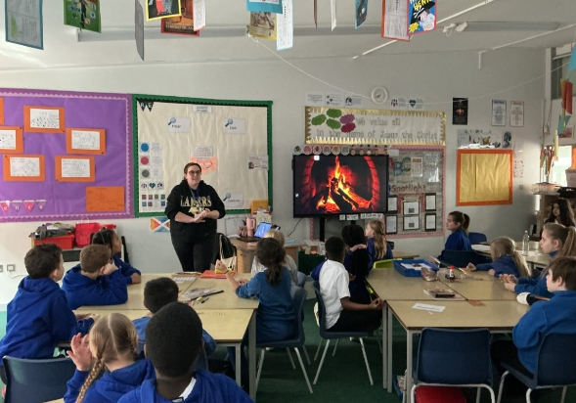
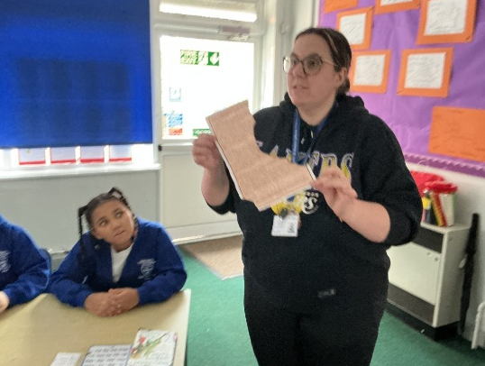

YEAR 6 have been working hard to understand area and perimeter. We have been looking at the language used for shapes, such as rectilinear, parallelogram, quadrilateral, regular and irregular shapes. As part of our topic on the circulatory system, we have been making blood and learning the properties that each part undertakes to keep us healthy: red blood cells, white blood cells, platelets and plasma. In English we have been looking at leaflets and their purpose to the public. We are going to learn how to make our writing more persuasive so we can write one of our own. We have been practising in groups.
